Medication Waste Reduction in an In-Hospital Pharmacy

BA638_Data Driven Decision Making & Optimization

Professor: Carol J. Cagle

Team 2 : Hien Do

Khanh Dang

Ravi Bandi

# **Business Obstacles**

A large academic hospital has faced some challenges while providing compound sterile medication (CSP) for both inpatients and outpatients. The process is less efficient in planning, communicating, and dispensing of CSP result in wastage of medication. This result in big obstacles for the hospital as annual waste of 47 thousand doses, and more than half a million dollars not including labor cost, disposal cost. There are for main parties are involved in the task of supplying CSP to patients. First, patients who received medications, CSP, treatment, but they faced some issues: moved units, condition changed after order was complete. However, same medication cannot be used for different patients as medication composition is customized according to patient’s condition. Second, health care providers who identify diagnose patient’s condition and ordered for medication. They cancel the medication, but they do not communicate to pharmacists. Third, pharmacist who check and verify the order, and tech who create the medication and deliver the medication to the hospital unit. They experience communication issues regarding to cancellation and update on patient’s condition and location.

# **Objectives**

The goals we are trying to achieve include improving the efficiency of scheduling of CSP preparation batches for twenty-four hours seven day a week (24/7) to keep up with cancellation updates and staffing accordingly. This will result in savings from cancelled medications and high quantity of medications that are delivered wrong places. Additionally, efficient scheduling also resolves the issues of moving units after order was placed, patient condition changed after order was completed, and mistaken order. The cost for extra disposal is high as $40/small container in Georgia, thus it is necessary to implement proper waste disposal. The logistical bottle necks and errors in delivery of CSPs to the patient’s location need to be reduced. Minimizing communication gaps between pharmacists, technicians, and hospital healthcare providers to reduce the issues of cancellation was not communicated to pharm and not alerted by Tech.

# **Analysis Scope**

CSP are expired in short time, the data does not mention about expiry of CSP (1 day or 2 or more) based on which how many doses can be prepared at one go can be decided. Duration between doses along with start and final time variables will help us identify how many and when doses must be administered.

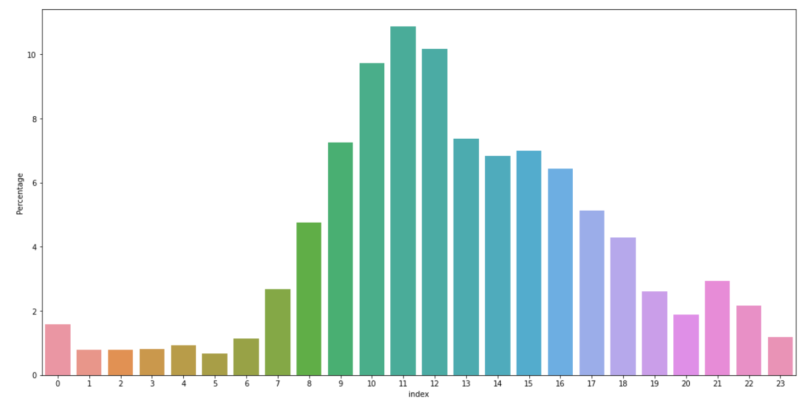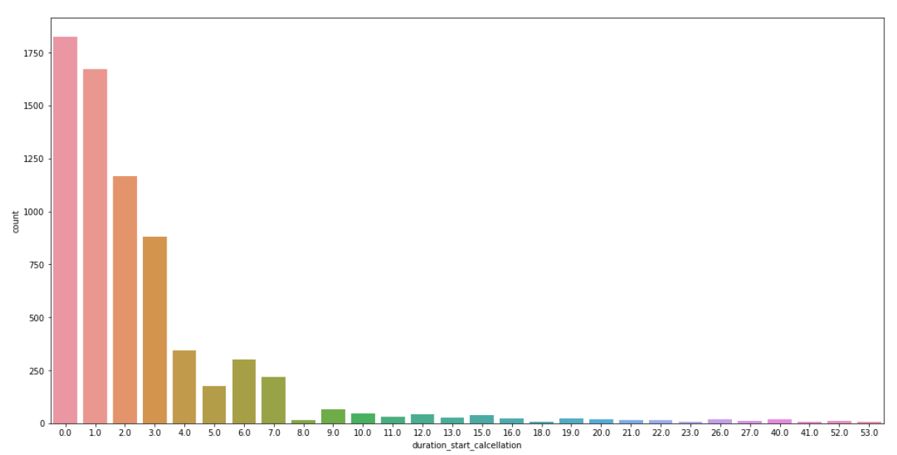

Figure 1. Time Cancellation Figure 2. Duration start cancellation

The rate of cancellations i.e., of 90% is higher from 7 AM to 7 PM with highest being 11AM to 12PM. The probable reason could be that the health care provider changes the patient’s medication based on the condition and their consultation hours are usually during the daytime. It takes time to confirm right medication to the patient, which is why more than 95% of cancellations are within a week after first dose.

# 

Figure 3. Drug ID Figure 4. Time Dose

The drug number 1 VANCOMYCIN has the highest probability of getting canceled (31%), and drug number 2 – 6 have the approximate probability of getting canceled within 9%-12%.

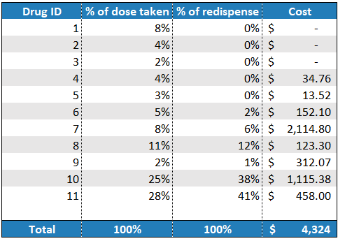

Figure 5. Cost of Re-dispense

Except for the mid night we are treating patients all the time with medications throughout the day. We are assuming that the CSPs are prepared one day before the start time of first dose. The number of doses prepared are also the doses that are enough for a day. We should also consider some cases where the medication is ordered during the CSP preparation time (6AM to 2 PM), in these cases is medicine prepared on the same day for that day treatment or next day is also assumed. The cost of medicines for current single batch that has been not used is $140,541.

Re-dispenses are doses that must be prepared to handle missing doses due to misplacement of the original doses in hospital units or insufficient number of doses supplied by the pharmacy. We will spread out technicians and pharmacists throughout the 3 batches. One extra pharmacist will be working during the 9-2 batch. Even though Drug 7 has been re-dispensing very less in units, the unit cost of this drug being higher made the overall cost of this drug getting re-dispensed higher than any other.

# **Action plans**

To achieve the objectives there are some action plans need to be in place. We will create three batches where the first batch starts from 6 AM to 2PM, second from 2 PM to 10 PM and in third 10PM to 6AM. Average medicine preparation time assumed to be 2 hours and 1 hour assumed for delivery. i.e., 3 hours.

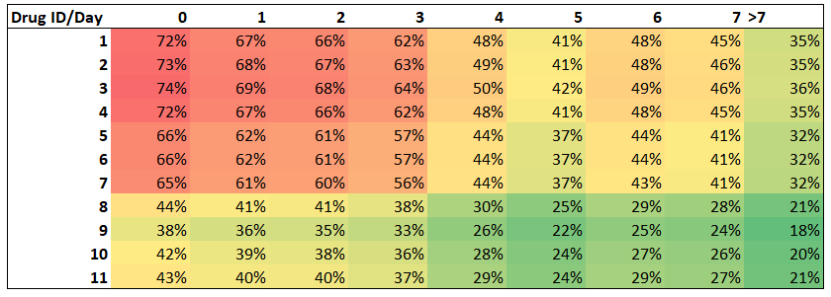

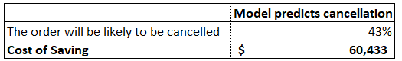

Based on daily cancellation times and medicine inducing times, we are implementing three batch 24*7 model where medications that are commonly cancelled with in first week are given priority of last-minute preparation. This will reduce generation of waste as any medicine we are uncertain to use is prepared just before use. This saves us 60K USD every year.

We should consider that this is most pessimistic model we have come up with, as we have assumed all the drugs, we have will be good for only two-day use in the old batch and also in new batch. Which means if the medicines are good enough for longer period the waste will be higher in Old model and savings will grow in new model. By saving waste generated we are also saving money in the form of payment done for disposal of medical waste. We can observe the cost saved from disposal of medical waste which illustrates in the table “saving cost of medical waste disposal” and it can be seen nearly $175,000 cost of pharma waste per year can be saved by new plans.

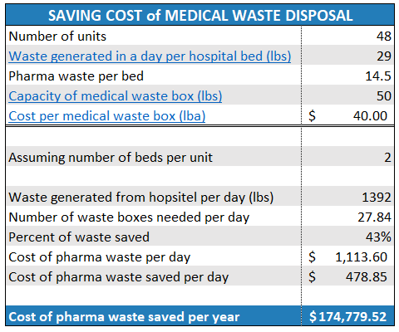



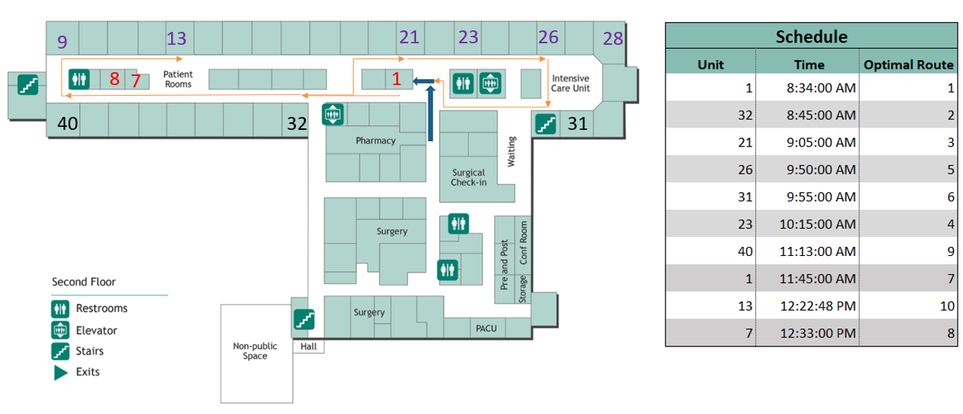

Before the implementation of the 3-batch system the pharmacy uses the pneumatic tube system of the hospital to deliver first doses. Then the IV batch are delivered by a tech using cart. But now we will be using tube system for delivery of drugs as we are preparing these CSPs on the same day as the usage. These pneumonic tube boxes are embedded with RFID technology and each box are assigned to specific locations of patient beds. If incase a box reaches incorrect location the tubes suck it back to send to correct location which is identified with the help of RFIDs.

Some medicines cannot be sent thorough for which we will use cart which is also embedded with RFID and entire hallway is embedded with RFID readers which directs the cart to destinations with optimized route.We should use color coding and nomenclature for better deployment of drugs. By using common route for the delivery of CSPs between hospital units we have identified that there are 50-60% of chances of optimization, based on which we can reduce the redisperse of medication by 55%.

Independent double checks must be implemented, should not rely on verbal orders, Computerized provider order entry (CPOE) systems seek to eliminate errors resulting from handwritten and verbal orders by having providers enter medication orders directly into the computer system. Label generation will also help reduce communication. Staff must be brought to consensus on common practices and avoid common errors such as below.

# **References**

[Kyle A Weant](https://www.ncbi.nlm.nih.gov/pubmed/?term=Weant%20KA%5BAuthor%5D&cauthor=true&cauthor_uid=27147879), [Abby M Bailey](https://www.ncbi.nlm.nih.gov/pubmed/?term=Bailey%20AM%5BAuthor%5D&cauthor=true&cauthor_uid=27147879), and [Stephanie N Baker](https://www.ncbi.nlm.nih.gov/pubmed/?term=Baker%20SN%5BAuthor%5D&cauthor=true&cauthor_uid=27147879) (2014), “Strategies for reducing medication errors in the emergency department”, <<https://www.ncbi.nlm.nih.gov/pmc/articles/PMC4753984/>>, Published online 2014 Jul 23. doi: [10.2147/OAEM.S64174](https://dx.doi.org/10.2147%2FOAEM.S64174)

Rama P. Nair, RPh; Daya Kappil, RPh; and Tonja M. Woods, PharmD (2010), “10 Strategies for Minimizing Dispensing Errors”,

<<https://www.pharmacytimes.com/publications/issue/2010/January2010/P2PDispensingErrors-0110>>